**POWER LEARN PROJECT DOCUMENTATION ASSIGNMENT**

**NAME:LAMECK KIPSANG**

**EMAIL:lameck.cs16@gmail.com**

1.I have my windows 10 fully installed as you can see by the screenshot below.

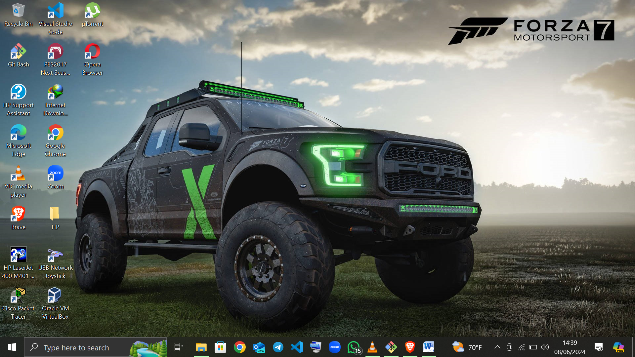

2.I downloaded my text editor Microsoft Visual studio code from its official website <https://code.visualstudio.com/Download> and installed it into my personal computer as you can see below.

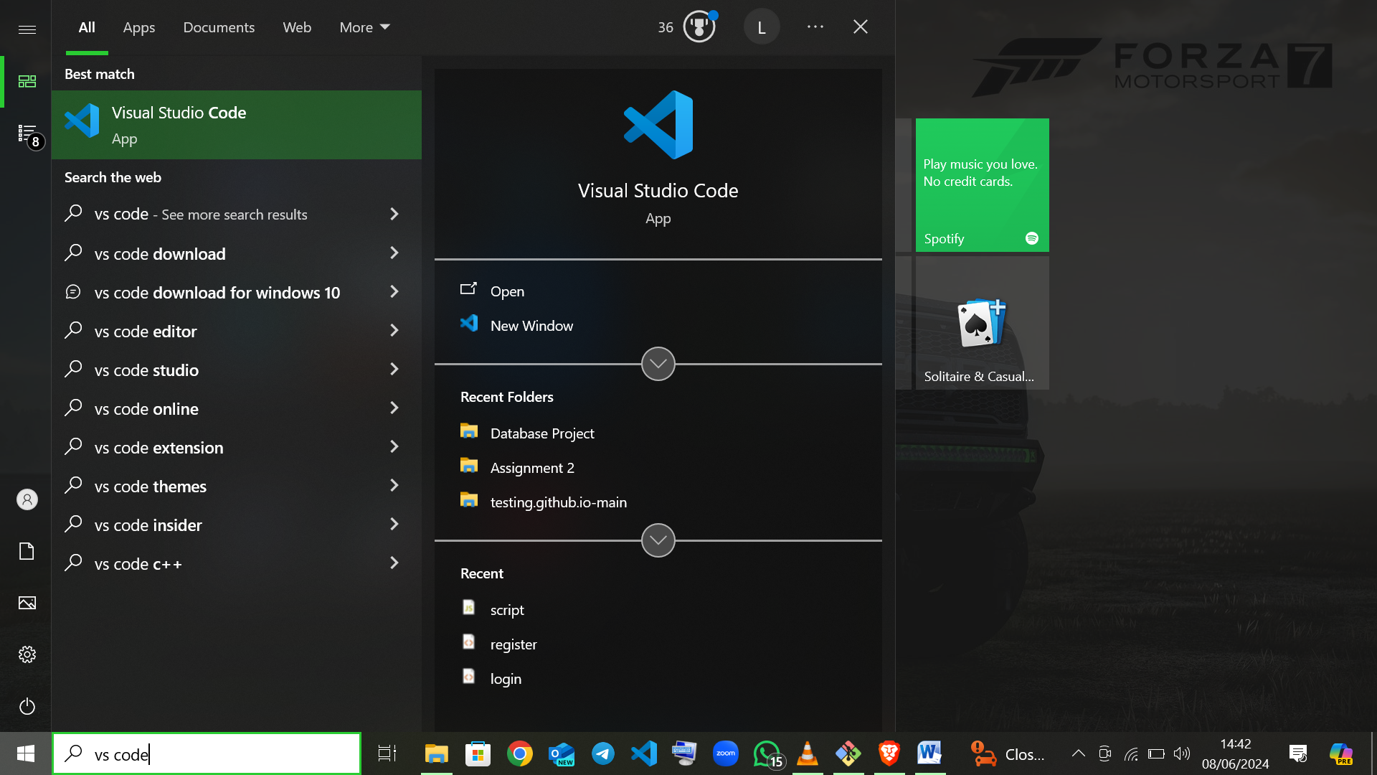

Here is also its location my windows machine.

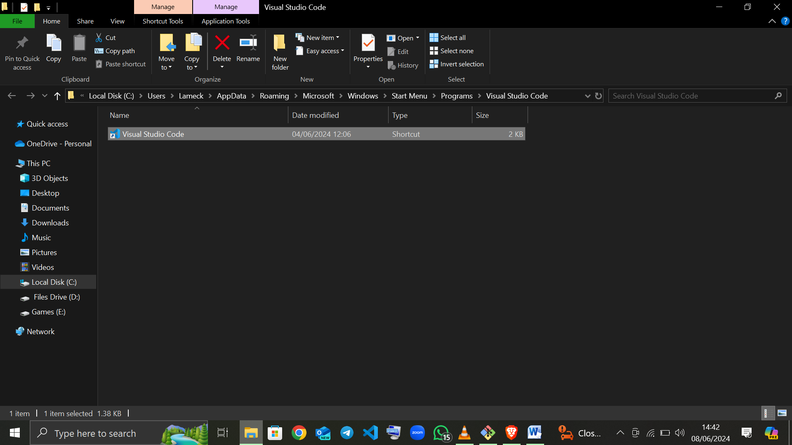

3.I also took a step forward in setting up my version control system by installing git for windows and configuring it in my local machine.I also initialized a git repository for my project as I have attached it a url and also made my first commit as shown below.

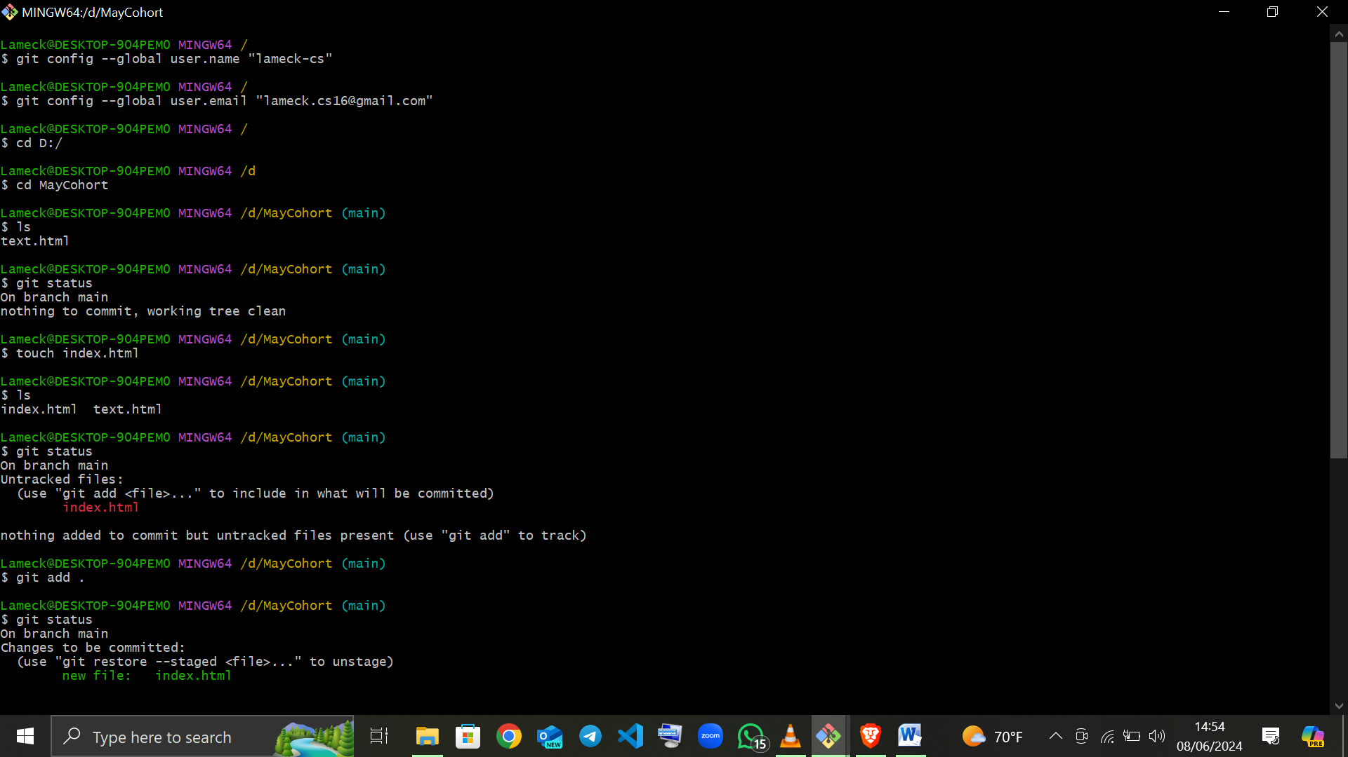

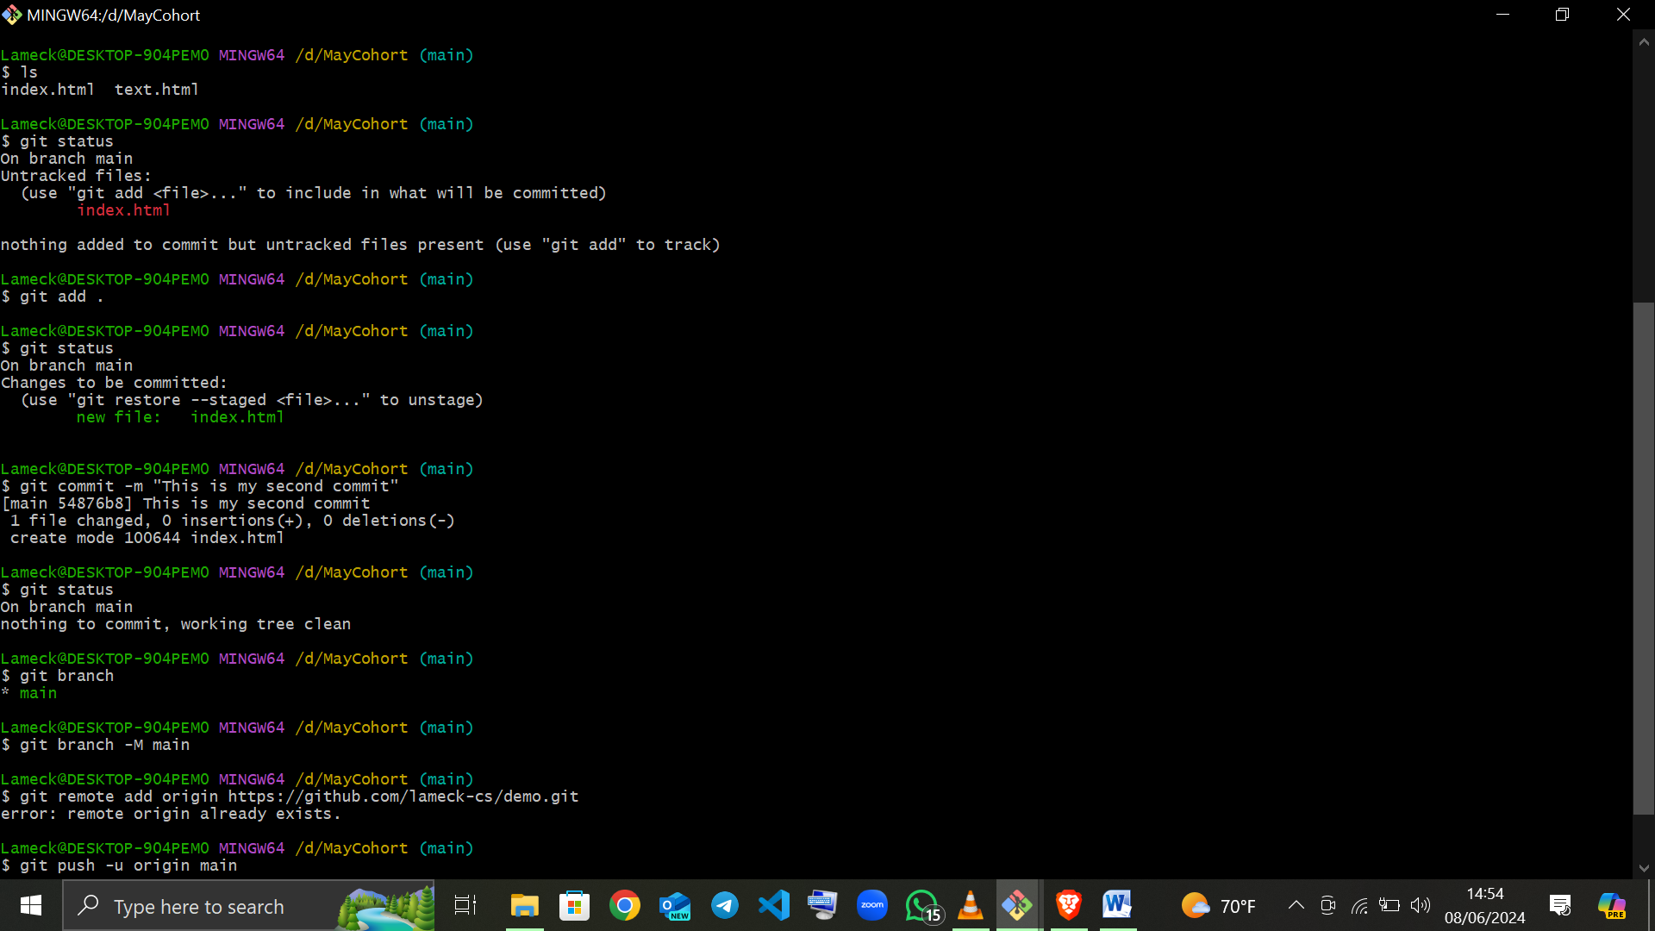

4.I also managed to install python from the official website <http://www.python.org> as shown below

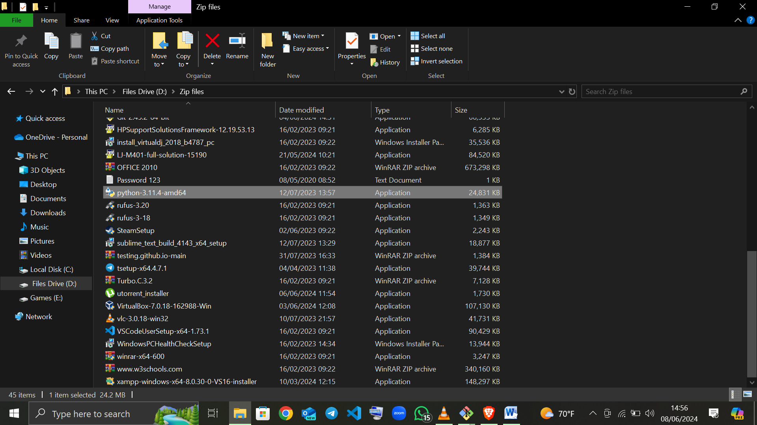

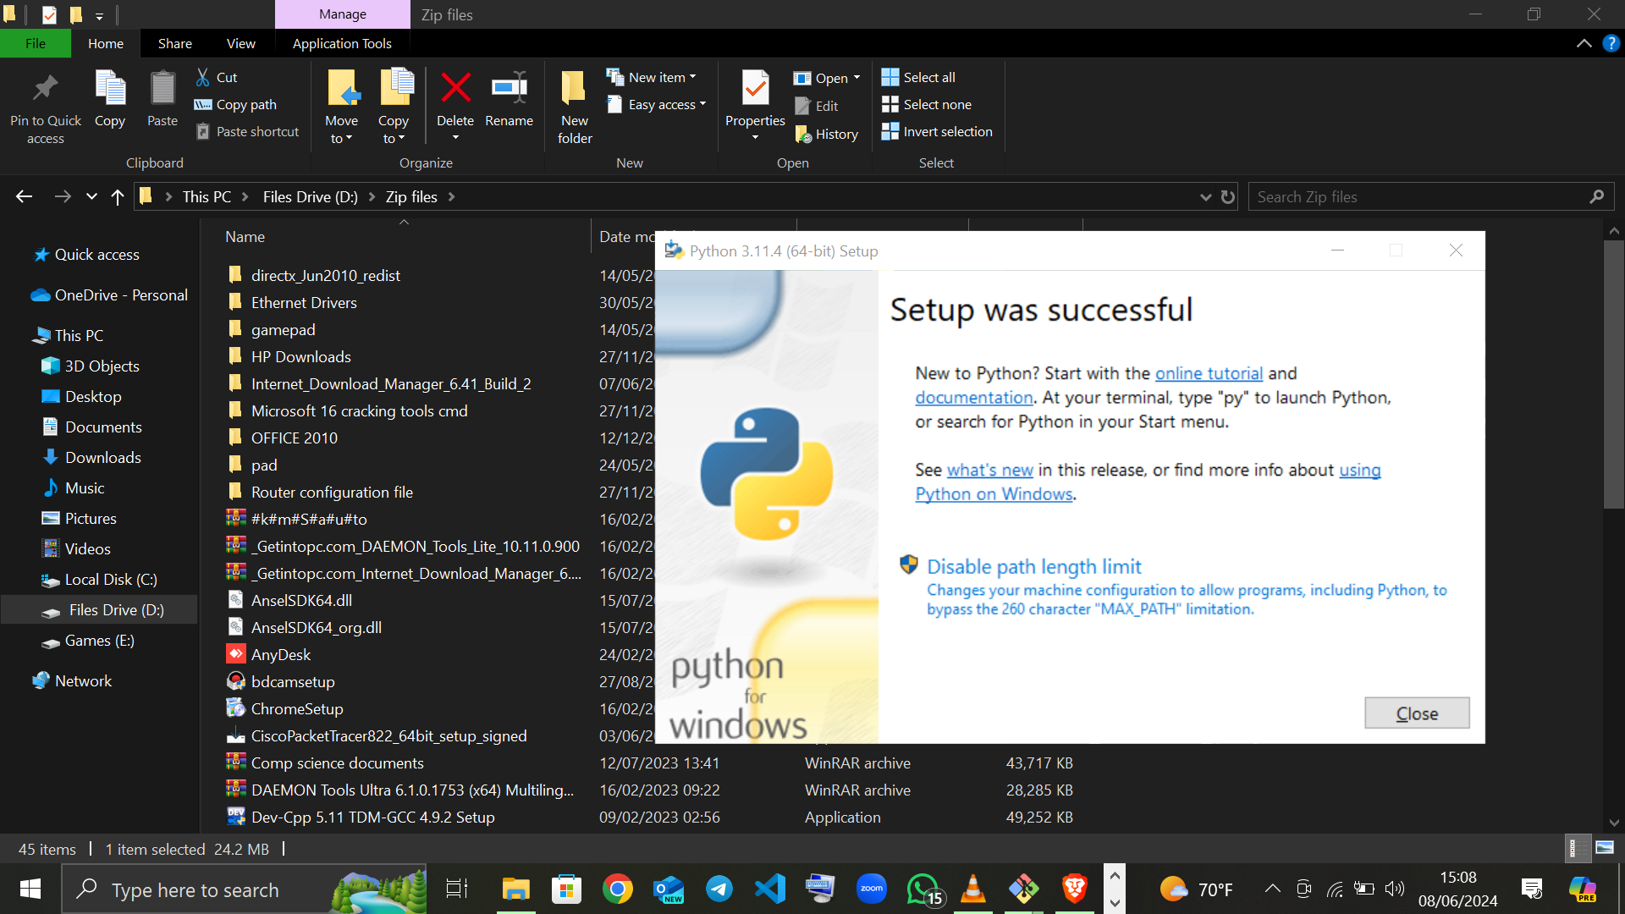

5.I went ahead to install packages for python in the extensions marketplace in Microsoft visual studio code as you can see below.

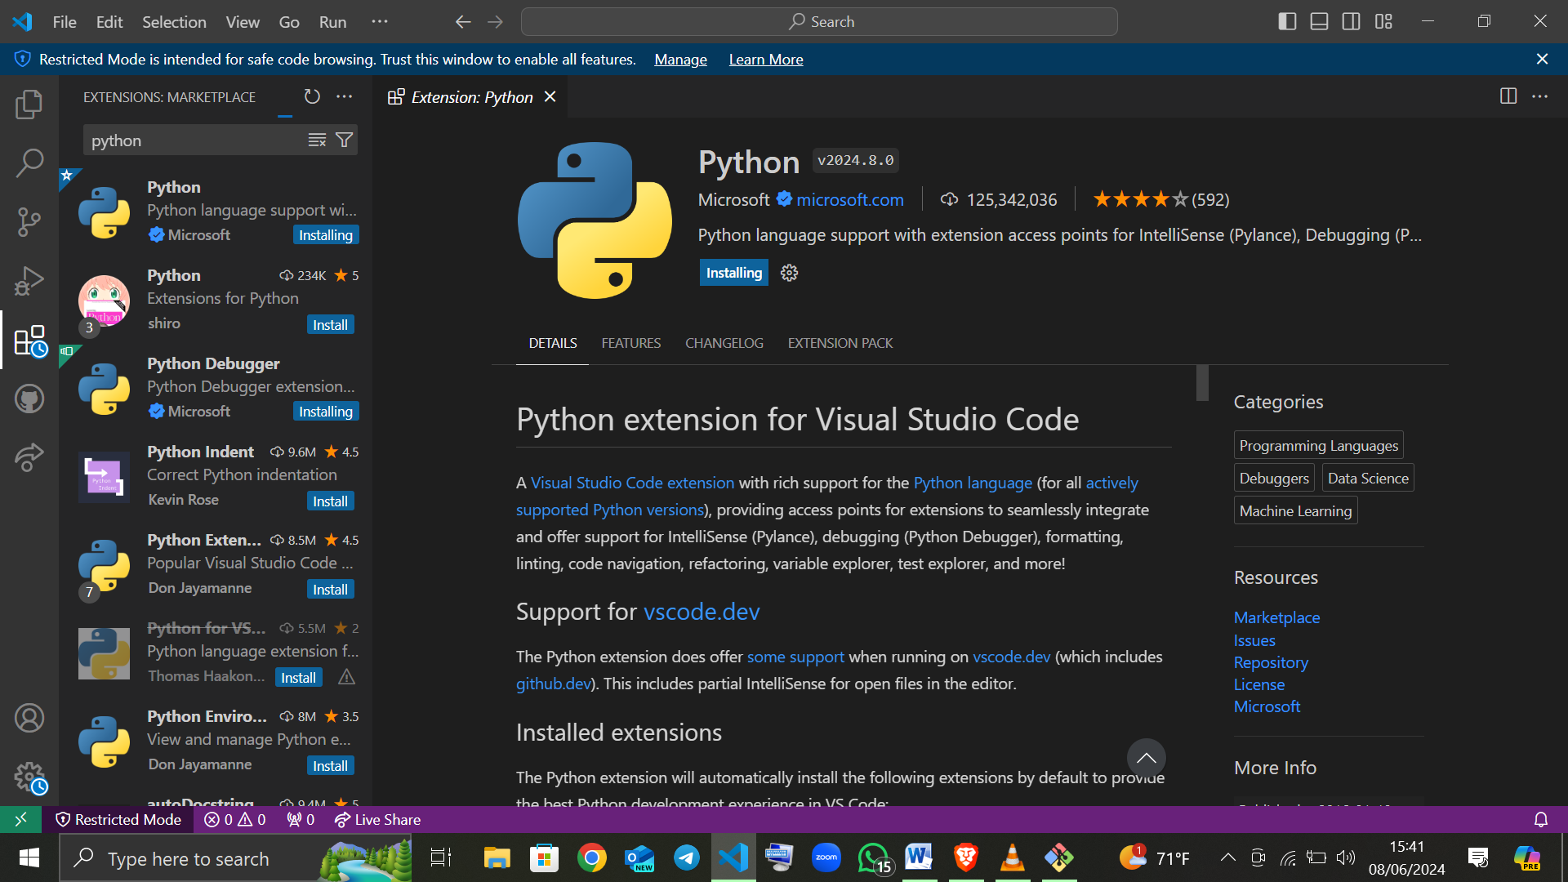

6.I also configured my database as shown below though I ran into some minor problems during installation.

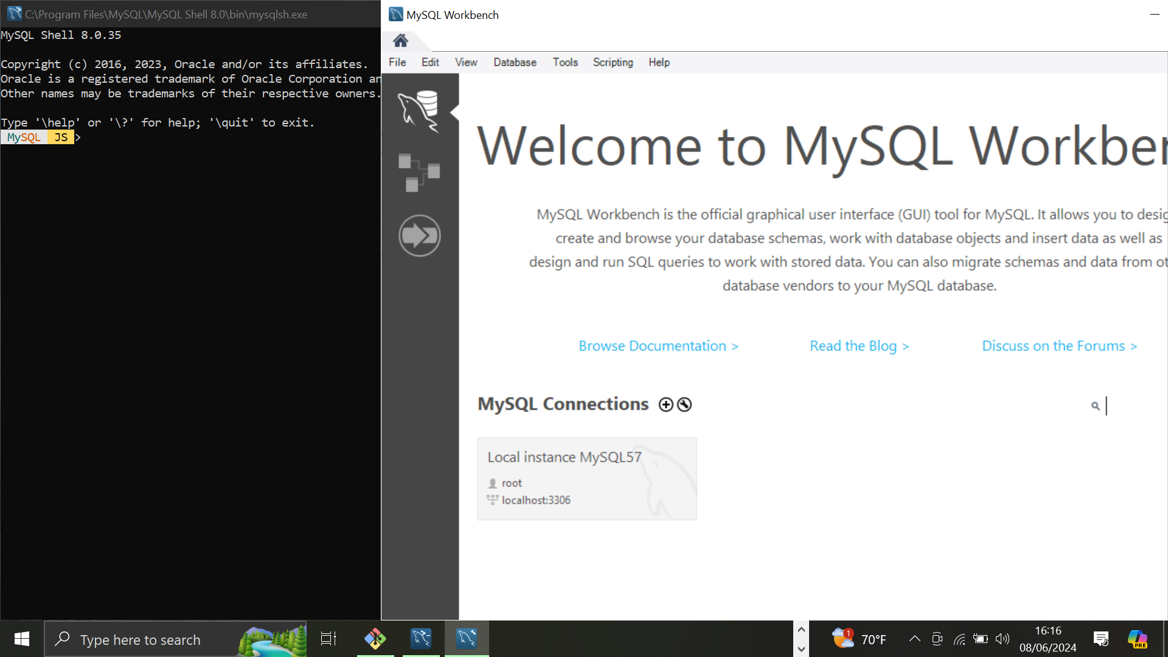

7.As you can see below I have a virtual linux environment through the help of Oracle vm virtual box

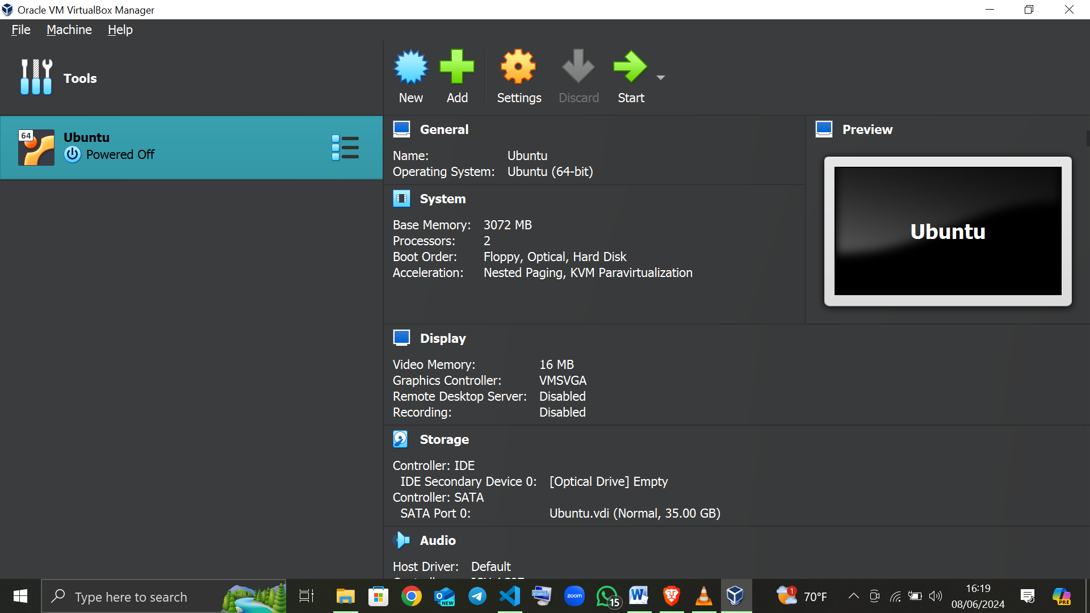

8.I have extensions on my text editor IDE Microsoft Visual studio code for example python extensions and Live server.

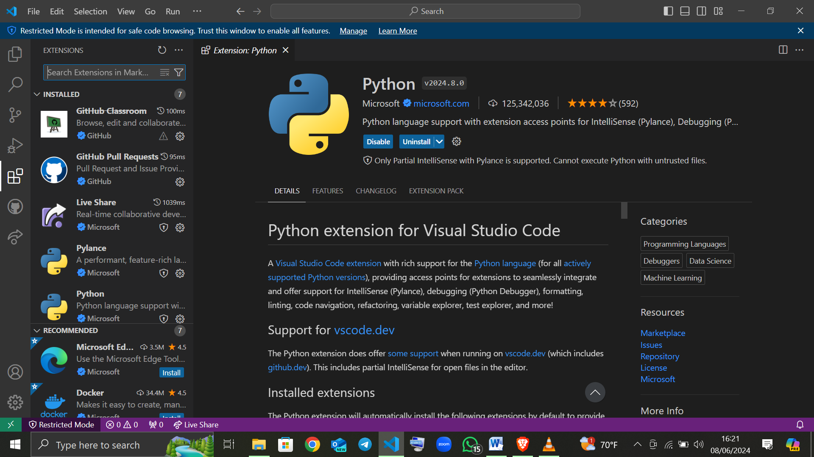

9. Some of the challenges faced during configuration and installation include the following:  
Executing the git push –u origin main command in git bash, solution was just turning off my virtual private network so as to get the authorization prompt.

During the installation and configuration of the msql database, establishing a working hosting server proved to be hard and more of tedious. I researched using the search engines and also chatgpt to be able to resolve the issue but was unable so I had to skip some installation processes.